LARA Bonecas Russas
Errata List
Version 1

Major notes
- All issues are marked in the score in pink.
- Minor issues where I have gone ahead and resolved based on context are marked in the score in orange.
- Green markings can be ignored – they are only for engraver reference.

Instrument | Bar | Issue | Answer
Trumpet | 59 | 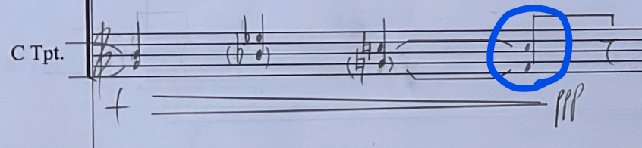  Does the trumpet tie from G to F natural? If so, should F be in parentheses? | Tie to G
Voice | 60 | According to Bonecas Russas Edits.docx, “M60, voice, beat 3: connect first and second G# with a tie”.  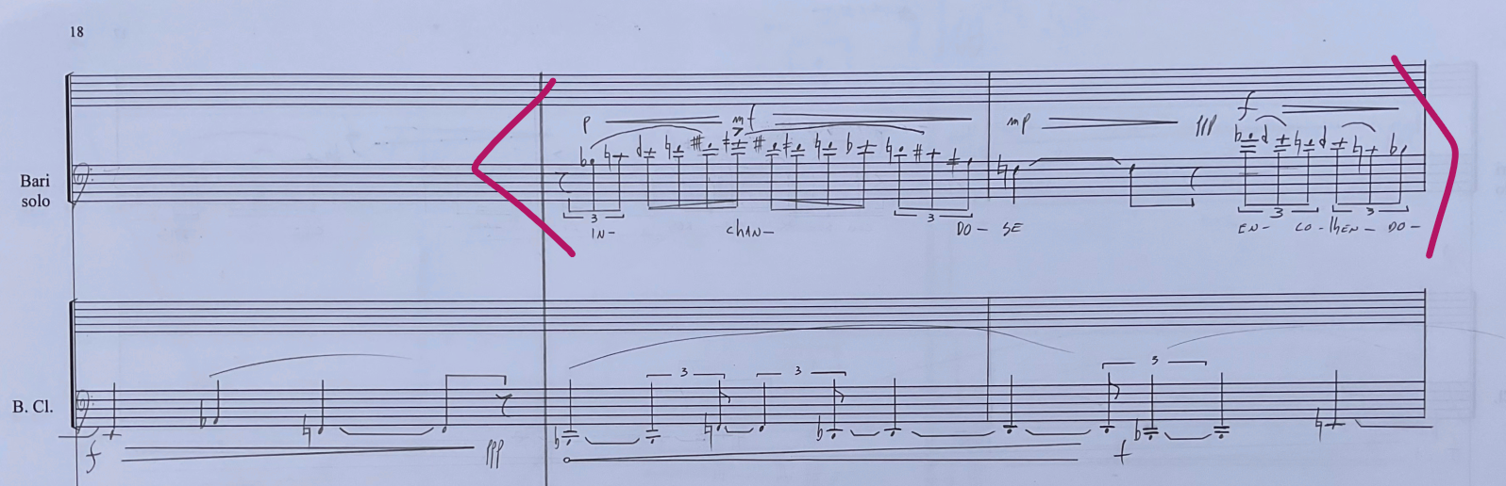  Are you referring to another passage? | Sorry, that was for M63, connect G# to next 32nd note there (missing in manuscript)
Trombone | 98, 105 | Spuccato (slap with lips) – I moved the ‘slap with lips’ instruction to the first occurrence of Spuccato in 98, instead of 105. Is that okay? | Yes
Trumpet | 140 | Beat 3 – can you check the rhythm

Additional erratas:

- M2, Bcl, beat 2, first note: should be B1/4 sharp, not sharp

- M5, Bcl, replace all Bartok pizz slap signs by X noteheads and marcato arrow, as M47

- M9, Bcl, beat 2 – add natural sign to low C, also Fermata should be on the low note, not barline. The comma should stay above barline

- M15, Bcl – clean up gliss arrow, colliding with rest on beat ; also beat 3, add natural

- M15, Voice, missing natural on beat 3

- M18, Bcl, missing natural sign on C (beat 3)

- M20-21, Bcl, missing natural sign on every C

- M20, tpt: missing natural sign on both C and G

- M20-22, Bcl, replace all Bartok pizz slap signs by X noteheads plus marcato arrow, as M47

- M20, tpt, notes on M20 and M21 should all connected/tied, delete all accidentals

- M24, Bcl, missing natural sign, same for 1st note of M25

- M24, trumpet and trombone: move mf to under rest before beat 4

- M24, beat 4, trombone, first note should be D nat, not D ¼ flat

- M26, voice and trombone, first note missing natural sign

- M27, voice, last note, please make legato slur on M28 start on Ab on end of M27 (where text sings “-do-”)

- M26-28, voice, make text closer to stave, too far as is

- M28, trumpet, beat 1, replace spelling E3/4 sharp, by F ¼ sharp

- M29, voice, clean up slur going over accidentals on beat 3

- M30, tpt, last note missing natural sign

- M30, voice, “uns” text should start on grace note F, not D

- M31, voice, beat 3, wrong spelling…should be “-tros”, not “tres”

- M31, Bcl, missing natural

- M30, tpt, last note (high C) missing natural

- M33, make “SPOKEN, SERENE, FREELY” into “Spoken, Serene, Freely”, like an expression mark

- M34, Bcl, missing natural
- M35, Tpt, G missing natural

- M36, Bcl, missing natural

- M37, tpt, first note missing natural

- M40, tpt, second note missing natural; last note (beat 4) should be A ¼ sharp, not sharp

- M41, Bcl, first note missing natural, also first note of M42

- M42, tpt, first 3 notes missing naturals

- M43, voice, beat 4, first note missing accidental ¾ sharp

- M45, tpt, low C missing natural

- M46, Bcl, add natural to low C….also add natural to M47

- M47, voice, wrong hyphen on “-do_”, from “re-pe-tin-do-“ beat 4, should be just
“-do-”

- M47, tpt, beat 2, F missing natural

- M48, trombone, beat 4, should be F1/4 sharp, not F#

- M48, tpt, beat 2, first note should be C natural, not C#; second note of beat 2 also wrong, should be F# 1/6 flat

- M49, tpt, last note should be E1/4 flat (not Eb)

- M50, Bcl, beat 2, missing natural sign

- M51, tpt, lowest note missing natural

- M51, Bcl, missing natural

- M53, tpt, F natural on beat 1 should be F ¼ sharp

- M54, bcl, missing natural

- M55, bcl, missing natural (also M57)

- M56, bcl, wrong note, should be Eb (not E nat)

- M59, tpt, beat 2, top note (F) missing natural sign

- M60, bcl, first note missing natural

- M61, bcl C missing natural

- M62, tpt, first F missing natural

- M64, bcl, low C missing natural

- M64, voice, highest note, wrong note, should be just high Ab 1/6 flat

- M67, tpt, both notes should be tied from M66

- M67, trombone, top F missing natural

- M67, bcl, missing natural

- M67, tbn, mute should go from closed to half-open by end of bar

- M68, tbn, beat 2, top E missing natural

- M69, voice, beat 1, last note text should be “bo-ne-ca”, not “do-ne-ca”

- M69, voice, beat 2, last note should be tied to beat 3

- M70, voice, beat 2, E missing natural

- M71, voice, beat 3, E missing natural

- M71, tbn, top note wrong on manuscript, should be just E tied from previous bar

- M72, voice, last syllable “i” should start on last F of beat 3 after rest, then be slurred until beat 1 M73

- M72, bcl, first note missing natural

- M73, tbn, wrong note, should be low C, don’t forget to add natural

- M74, voice beat 2, first note should still be B nat, not Bb

- M74, tpt, beat 1, second triplet, please add natural on D

- M75, tpt, beat 3, add natural to F

- M76, bcl, add natural to both low and high Cs

- M77, tpt, beat 2, note in green is wrong, should be just F 1/6 flat

- M78, bcl, beat 2, add natural to G

- M79, bcl, beat 1, add natural to C

- M80, tpt, first note should be just tied from B1/4 sharp from bar before

- M80, tpt, make grace note into F (better than E#)

- M80, tbn, mute should be at half-open by beginning of bar and full open by end of bar

- M81, voice, either delete “(ossia)” or move to first time the parenthesis happens in the bars before.

- M82, tpt, last note, should be A1/4 flat (not Ab)

- M82, tbn, beat 3, crescendo should start immediately after beat 3 (not beat 4)

- M82, bcl, beat 2, C missing natural; same for beat 3

- M83, bcl, low C missing natural

- M83, tpt, first note wrong, should be Bb 1/6 flat

- M84, tpt, beat 2, add natural to F

- M85, bcl, beat 4, delete treble clef, its redundant

- M86, tpt, beat 3, make E# into F

- M87, tpt, first note should be tied from M86

- M87, tpt, beat 2, clean up accidental on E 1/6 flat…covered by dynamics

- M87, tpt, beat 4, make notes F nat, and E ¼ flat

- M89, bcl, add natural to low C

- M90, bcl, beat 2, should be Bb…then beat 3 the G is missing natural

- M91, tpt, beat 1, both notes missing natural

- M92, bcl, beat 2, low C missing natural

- M93, bcl, last note low C missing natural

- M94, tbn, notes should be tied and missing dynamics altogether

- M97, tbn, first two notes should be tied from M96

- M98, tbn, make all slaps X noteheads with marcato arrow, like previously on Bcl, for consistency

- M99, tbn, second note should be G ¼ flat

- M100, tbn, beat 2, dynamics for top note should be sub p, sfz should start on low D

- M101, tbn, beat 2, lower layer, last note should be high B1/4 flat; then note after should be D1/4 flat

- M103, tbn, add dynamics mf in the beginning of bar with dim to pp by the end of bar, then M104 make ff into ffsub

- M105, bcl, G should be an octave above, also fix slap to X notehead with marcato for consistency

- M106, voice, beat 2, text should be “dor” (not bor) and not connected through hyphen to “da”

- M107, tpt, add natural to C

- M106 and 107, bcl, both Gs should be an octave above, also fix slap to X notehead with marcato for consistency

